Wood Truss Roofs

Wood trusses spanning long distances make it possible to construct buildings with large, unobstructed floor areas. Common uses for buildings of this type include drive sheds, barns, and riding arenas like the example pictured below:
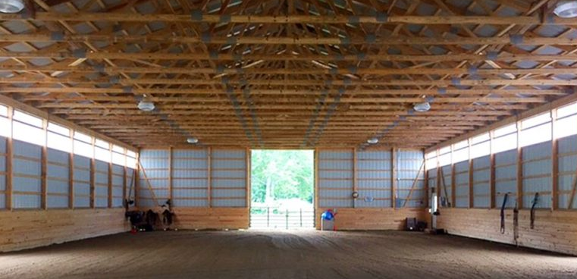
Buildings constructed in Ontario must be engineered and constructed to withstand expected snow loads for this area – including the wet, heavy, snow often encountered as February gives way to March and milder, damp weather settles in.
Recent incidents of building collapse raise the question of why, then, do structures fail, if requirements to design and build them to suit our weather conditions are in place?
One reason is that buildings age, just like people and horses. Heat, cold, wind, rain, and snow all take their toll, in different ways, on a building’s structural integrity. This process occurs gradually over a long period of time and often goes unnoticed by us – until something fails.
Another reason is the lightweight construction of wood roof trusses. Roof structures in older barns tended to be very “overbuilt” with large, heavy timbers. These could only span relatively short distances due to their size and mass. A wood roof truss, by comparison, is very light and flexible when considering the distance that it can span (as much as 60 + feet in many buildings) and is just one of many components in a carefully designed, engineered system. All components of this system must be in good condition for a wood truss roof to function properly. As a building ages, some components of the wood truss roof can begin to deteriorate and no longer carry their share of the workload. Over time, this places additional load on the remaining components and the roof eventually fails, sometimes under what would be considered a “normal” snow load.
Basic wood roof truss terminology is illustrated below. Note that a wood roof truss is made from many smaller wood pieces joined together by metal fasteners:

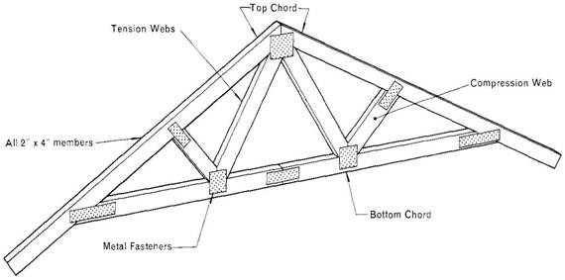
These fasteners, referred to by various names including gang nails or connector plates, are usually made from galvanized sheet metal and have sharp barbs on one side that are driven into the wood. A fastener is used on both sides of each connection where the wood pieces meet. The integrity of each connection is dependent on how securely each barbed fastener “bites” into the wood:
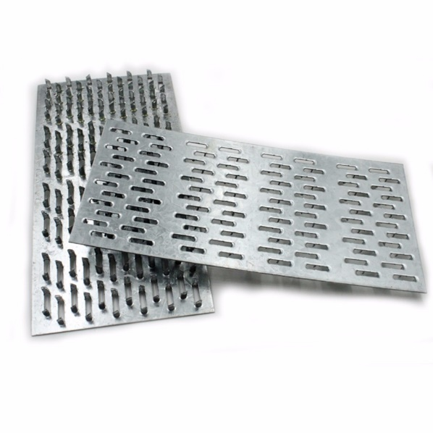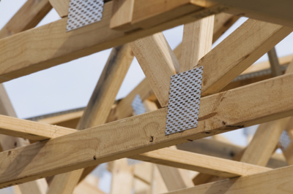

Although these barbed plates may appear flimsy, it actually requires thousands of pounds of force to drive them into the wood at each joint when trusses are assembled at the factory.

To create a strong roof assembly, the individual trusses are then joined together by wood strips running the length of the building. These strips, secured to each truss, prevent the trusses from flexing sideways and the strips attached along top chord of truss also provide a surface to which roof covering can be attached. Photo below shows a typical roof with wood trusses, 2x4’s tying bottom chords of trusses together, and sheet metal roof covering secured to wood strips along top chords of trusses:

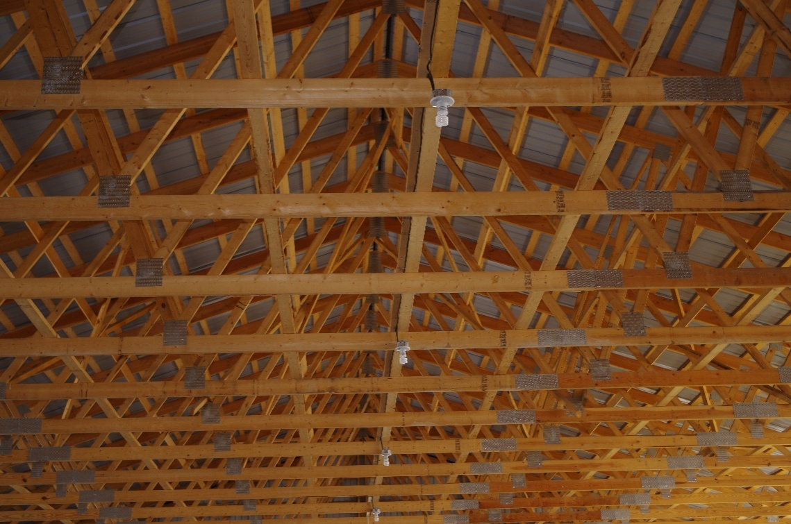

As designed, engineered, and built, a wood truss roof works well as an economical means of providing shelter over a large open floor space.
As described previously, a wood truss roof is a system which is dependent on each component being in good condition and carrying its share of the load.
Following are some examples of truss roof components which are in poor condition. (Please note that while the images may not be specifically of barn or arena truss roofs they do provide a good visual reference to compare with trusses in your own buildings.)

Metal connector plates can begin to separate from the wood members. This occurs over time as a result of changes in wood moisture content and expansion/ contraction of the truss members:
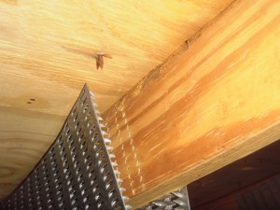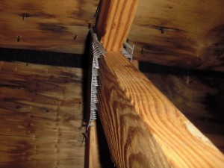

A truss web member that has cracked and broken away from its connection with the top chord members is shown here. Note that barbed metal connector plates are secure but end of truss web member has broken off:
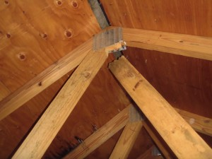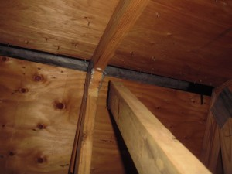

Truss web members have deflected downward and pulled free from connector plates:
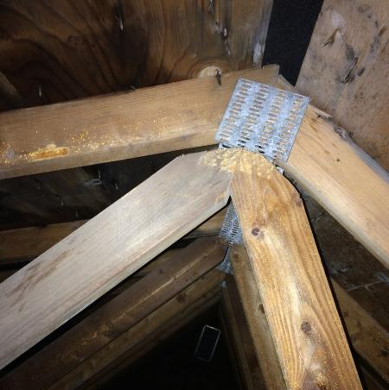

Diagonal web member has broken. Connector plates are still securely attached:
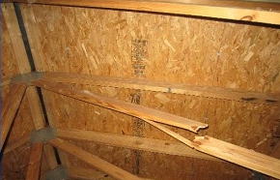
This last example shows roof trusses in an under-construction building which have been out in the weather for an extended period of time. Note how far some of the connector plates have pulled away from the wood. The majority of our farm buildings are unheated and while their roof trusses will not be exposed to direct sunlight or rain to this extreme they do experience wide variations in humidity and temperature throughout the year which will, over time, cause expansion/ contraction and begin to work connector plates loose:
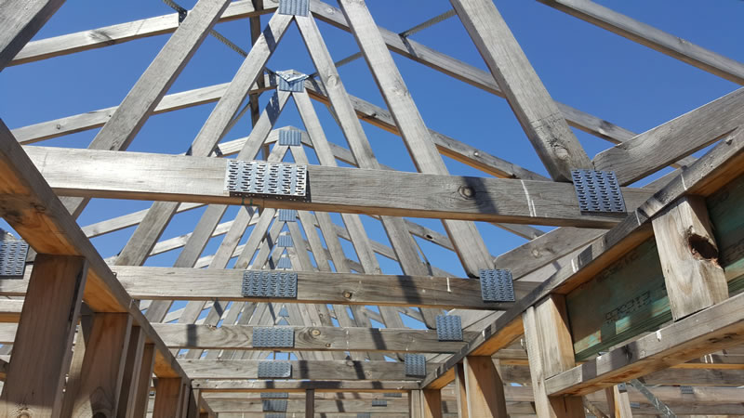

If your arena or barn has a wood truss roof, give it a thorough visual inspection. If you see signs of deterioration similar to the examples pictured above, contact a building construction professional and have proper repairs done - remember that roof trusses are engineered components, and repairs or alterations must be performed by a registered professional.

Beverly Sheremeto and Robert Nagle

